Article Type Open Access

Title of the Article (16 pt, Times New Roman, Bold)
First Author^{1,}*, Second Author², Third Author³ (12 pt, Times New Roman)
^{1*}Department Name, Name of College/School/Institute, Name of University, City, Country. (10 pt, Times New Roman, Italic)
² Department Name, Name of College/School/Institute, Name of University, City, Country. (10 pt, Times New Roman, Italic)
³ Department Name, Name of College/School/Institute, Name of University, City, Country. (10 pt, Times New Roman, Italic)
Keywords |  | Abstract
Keywords (must be given) contain Four to six words/phrases in alphabetical order separated with coma. (9 pt) |  | Abstract contains the scope and methodology employed and key results in complete and simple sentence and should not exceed 250 words and should be justified. (9 pt)  Note: Please do not use Citations and special symbols, mathematical formula and equations in abstraction section.

Introduction (11 pt, Times New Roman, Bold)
A brief and precise literature review with the objectives of the research undertaken and essential background should constitute the introduction part. (10 pt, Times New Roman)

Material and Methods (11 pt, Times New Roman, Bold)
Relevant details should be given including experimental design and the technique(s) used and clearly indicate the statistical methods used to summarize information for interpretation. (10 pt, Times New Roman)

Results and Discussion (11 pt, Times New Roman, Bold)
In result and discussion new findings, new interpretations etc. should be clearly spelt out and also confirmation of important concepts, models, theorems etc. should be indicated. It should be coherently presented and appropriately linked to tables, figures and other illustrations, but restricted to the bare minimum. Present data according to standard formats as dictated by the experimental design and the data analysis carried out. (10 pt, Times New Roman)

Conclusion (11 pt, Times New Roman, Bold)
The main findings of the investigations reported in the paper and briefly discuss the limitations of the research and Future Scope for improvement. (10 pt, Times New Roman)

Acknowledgments (11 pt, Times New Roman, Bold)
This heading is not assigned a number. An acknowledgement section should be brief and placed at the end of the text before the references, if desired. (10 pt, Times New Roman)

Conflicts of Interest
Authors must identify and declare any personal circumstances or interest in the manuscript in a paragraph heading "Conflicts of Interest" (after Acknowledgment section and before References). If there is no conflict of interest, please state "The authors declare no conflict of interest."

References (11 pt, Times New Roman, Bold)
This heading is not assigned a number. Only cited text references are included. Each reference is referred to in the text by a number enclosed in a square bracket (i.e., [3]). References must be numbered and ordered according to where they are first mentioned in the paper, not alphabetically.
Unless there are six authors or more give all authors' names; do not use “et al.”. Papers that have been accepted for publication should be cited as “in press”.
For papers published in translation journals, please give the English citation first, followed by the original foreign-language citation.
Some examples (10 pt, Times New Roman):
Article in Scientific Journal:
[1]. Author, A.A., Author, B.B. & Author, C.C. (Year). Title of the article. Abbreviated journal title, volume(issue): firstpage-lastpage. DOI of the article
Journal article in press:
[2]. Author, A.A., Author, B.B. & Author, C.C. (Year). Title of the article. Abbreviated journal title, volume(issue): firstpage-lastpage. (In press)
Book:
[3]. Author, A.A. (Year). Title of the book (edition). Location: Publisher.
Book Chapter:
[4]. Author, A.A. (Year). Title of the chapter. In: A.A. Editor & B.B. Editor, (Eds.), Title of the book (edition) Location: Publisher, pp. firstpage-lastpage.
Dissertation/Thesis:
[5]. Author, A.A. (Year). Title of dissertation/thesis. Name of institution, Location.
Proceedings Papers:
[6]. Author, A.A. (Year). Title of paper. In: A. Editor & B. Editor (Eds.), Title of proceedings, Location of conference, Publisher. pp. firstpage-lastpage.

Headings and Subheadings: Headings and subheadings, starting with "1. Introduction", initially capitalized and should be set in bold and aligned left. All headings from the Introduction to Conclusion are numbered sequentially using 1, 2, 3, etc. Subheadings are numbered 1.1, 1.2, etc. If a subsection must be further divided, the numbers 1.1.1, 1.1.2, etc. The font size for heading is 11 points bold face and subsections with 10 points. Do not underline any of the headings, or add dashes, colons, etc.

Figures: To ensure a high-quality, diagrams and lettering must be computer-drafted. Figure captions appear below the figure, and are in lower case letters. When referring to a figure in the body of the text, the abbreviation "Fig." is used. Figures should be numbered in the order they appear in the text.

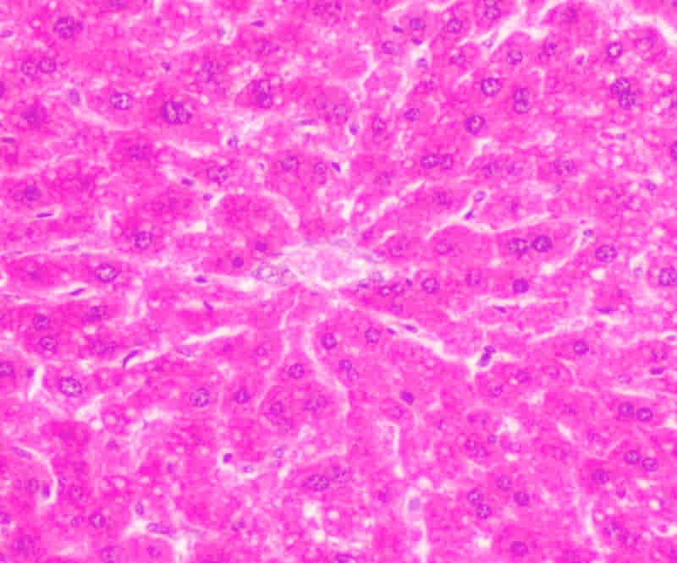
Fig. 1: Figure Label.
Table: Table captions appear centered above the table in upper and lower case letters. When referring to a table in the text, no abbreviation is used and "Table" is capitalized.
Table 1: Table Label

Equations and Units: All equations are numbered and referred to in the text solely by a number enclosed in a round bracket (i.e., (1) reads as "equation 1"). Equations should be indented at the left margin and numbered at the right margin and defined in a clear and understandable way. Ensure that any miscellaneous numbering system you use in your paper cannot be confused with a reference [1] or an equation (1) designation. SI Units (International System of Units) should be used. Other units should be converted to SI units whenever possible.

$a^{2}+b^{2}=c^{2}$ (1)

Page Numbering, Headers and Footers: Do not include headers, footers or page numbers in your submission. These will be added when the publications are assembled.

